 | Port Augusta Secondary School – Mathematical Investigation
Task Title
Game Investigation
 | Teacher | Year Level  Year 8 | Due Date  Friday Week 7

Task Description
In looking at some games of any type you can classify them into a number of categories
- Games of Luck – Games where chance plays a significant role, for example ones that use rolls of dice, flips of coins etc.
- Games of Skill – The more you play the game and the more you learn about it the better your chances are of developing a winning strategy, most sports like football, netball and basketball are games of skill, so is chess.
- Fixed Games – Ones where the outcome is the same every time, no amount of luck or skill can change it. These games are not so common because if you know the outcome before you start, then why would you play the game.
You will investigate the game below, it is a fixed game, and once you know how it works you will know the strategy to take to win every time (assuming the person you are playing does not know the game). The aim of this investigation is to determine a strategy to ensure you always win. The rules for the game are below.
- One of the players decides on how many starting crosses there will be and the other player decides who will go first.
- Start by drawing the agreed number of crosses onto the paper
- Player 1 goes first by connecting any two of the arms of the crosses together with a line and drawing a slash through the centre of the line to create two new arms
- Player 2 then has their shot again connecting any two open arms (ones not already connected to a line) and drawing a slash through the middle. You must ensure that the line drawn does not cross over any of the previously drawn lines.
- Play continues until you cannot connect any two open arms. The last person to have a legal shot is the winner.
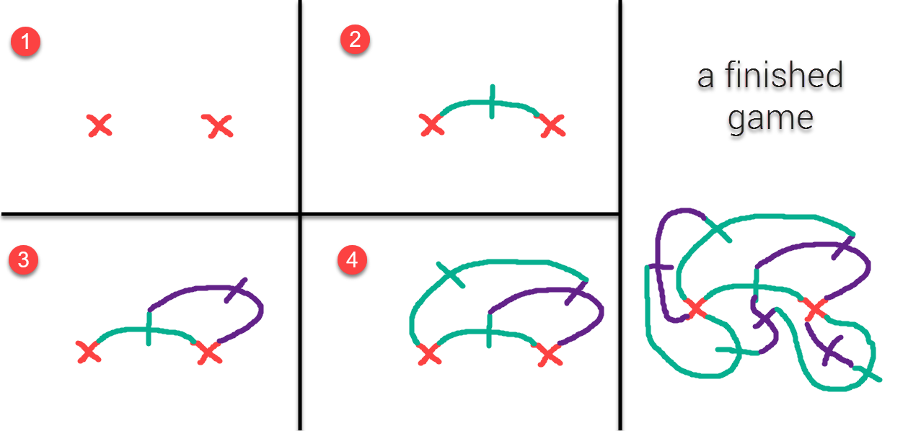
Your investigation must be completed on the template provided.
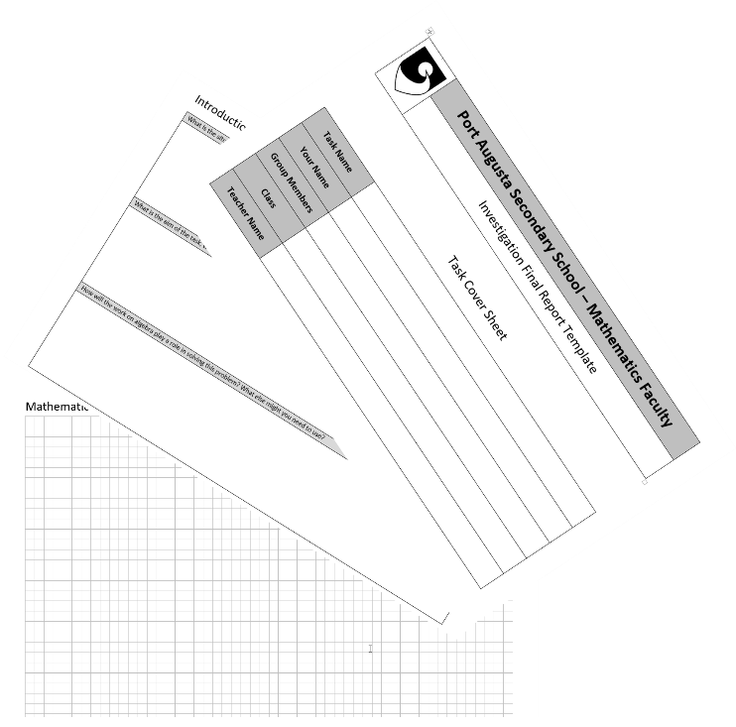
Mathematical Results
This game can be investigated in one of two ways. The first way is by playing the game, looking at the results and looking for the patterns. The second way is by looking at the games in terms of a well-known mathematical identity, Euler’s Rule, this does not require you to play the game. This second option is more difficult as it requires much deeper thinking about the underlying concepts. Completing the first variation of the assignment is definitely level 1 but could be level 2 if done well enough, the second variation is level 3, but depending on how well it is done could also be level 2.
Option 1 - Playing the game (Level 1/2)
One way to determine the optimal strategy for this game is to play the game and to look at the results of the game trials
- First decide on how many times you are going to vary the number of crosses. You must decide on a number that you feel will give you sufficient information about the game and what effect changing the starting crosses has. For example you may choose to only play games for 1, 2 and 3 starting crosses, or you may decide that that is not enough and that you need to use more.
- Next decide on how many times you will play the game for each number of crosses. You must decide on a number that you feel will give you sufficient information about that number of crosses. For example how many times do you think you will need to play the 1 cross game, just once? Three times? More than 3?
- Design a way to records your results of the game trials.
- Describe the patterns of results that you notice for the game.
- Represent the relationship between the number of starting crosses and the number of moves required to win in at least two different ways.
- What strategy could you use to make sure that you always win this game?
- How many moves would a game starting with 48 crosses last?

Option 2 - Analysing the game using Euler’s Rule (Level 2/3)

To look at the perfect strategy for this game it is possible to find it out without even having to play the game at all (although you may want to play the game to check the model you develop). The game itself is an example of a graph that can be analysed using Euler’s Rule this rule is as follows

$$V-E+F=2$$

V = number of vertices
E = number of edges
F = number of faces

For steps 1 to 3 there is a video on my website that will help develop your understanding of these questions

- Define the number of vertices (V) in terms of the number of starting crosses C and the number of moves (M). Repeat this process for edges (E) and faces (F).
- Substitute the definitions above into Euler’s Rule and simply it as much as possible.
- What does question 4 tell you about the relationship between the number of starting crosses and the number of moves required to win.
- Represent your relationship in at least two other ways.
- What strategy could you use to make sure that you always win this game?
- How many moves would a game starting with 48 crosses last?

Conclusion – Use past tense.
- Summarise the mathematical work done on the task and the extent to which the aim has been achieved.

Technical Vocabulary
The following words should be used accurately within the completion of the task. When you use them you should show that you clearly understand them.
- variable | - relationship | - strategy | - model

Year 8 Maths Investigation Rubric
 | Understanding | Fluency | Problem Solving | Reasoning | Structure | Language
A | ☐ High level of understanding of mathematical concepts.  ☐ Able to make strong connections between related concepts  ☐ Able to adapt concepts to new contexts and ideas. | ☐ High level of skill in choosing appropriate procedures  ☐ High level of recall of factual knowledge.  ☐ Procedures were consistently used flexibly, accurately, efficiently and appropriately | ☐ Innovative or insightful strategy to solve the problem  ☐ All steps in process were justified, explained, well organized, detailed and articulated.  ☐ Large repertoire of problem solving strategies | ☐ High level of logical thought  ☐ Strong ability to analyze, prove, evaluate, infer, justify and generalize. | ☐ Strictly adheres to the required structure. All information set out well, easy to find and identify  ☐ Introduction clearly identifies the aim, what is being done and why.  ☐ Conclusion outlines what has been found and connects it to the aim | ☐ Personal language (e.g. me, I, we, us) is consistently and accurately removed from the text  ☐ All technical vocabulary is used effectively and accurately throughout the task
B | ☐  Work exceeds a C but is lower than an A  ☐  ☐ | ☐  Work exceeds a C but is lower than an A  ☐  ☐ | ☐  Work exceeds a C but is lower than an A  ☐  ☐ | ☐  Work exceeds a C but is lower than an A  ☐ | ☐  Work exceeds a C but is lower than an A  ☐  ☐ | ☐  Work exceeds a C but is lower than an A  ☐
C | ☐ Satisfactory level of understanding of mathematical concepts.  ☐ Sometimes able to make connections between related concepts  ☐ At times able to adapt these to new contexts and ideas. | ☐ Satisfactory level of skill in choosing appropriate procedures  ☐ Satisfactory ability to recall factual knowledge.  ☐ Carries out procedures flexibly, accurately, efficiently and appropriately with some general effectiveness | ☐ Effective strategy to solve the problem.  ☐ Mathematical thinking was appropriately documented however explanations lacked detail, articulation and/or organization  ☐ Evidence of a range of problem solving strategies. | ☐ Satisfactory level of logical thought  ☐ Some ability to analyze, prove, evaluate, infer, justify and/or generalize. | ☐ Mostly adheres to the required structure. Information generally set out effectively  ☐ Introduction clearly identifies the aim and what is being done but not why.  ☐ Conclusion outlines what has been found without connection to the aim. | ☐ Satisfactory attempt made to remove personal language (e.g. me, I, we, us) from the text  ☐ Technical vocabulary is included in the task with some degree of accuracy
D | ☐  Work exceeds an E but is lower than a C  ☐  ☐ | ☐  Work exceeds an E but is lower than a C  ☐  ☐ | ☐  Work exceeds an E but is lower than a C  ☐  ☐ | ☐  Work exceeds an E but is lower than a C  ☐ | ☐  Work exceeds an E but is lower than a C  ☐  ☐ | ☐  Work exceeds an E but is lower than a C  ☐
E | ☐ Little or no understanding of mathematical concepts.  ☐ Unable to make connections between related concepts  ☐ Unable to adapt these to new contexts or ideas. | ☐ Little or no skill in choosing appropriate procedures  ☐ Little or no ability to recall factual knowledge.  ☐ Not able to carry out procedures flexibly, accurately, efficiently or appropriately in most situations. | ☐ Ineffective and inappropriate strategy to solve the problem.  ☐ Mathematical thinking was not documented, or was only documented to a limited extent. | ☐ Little or no logical thought  ☐ Little or no ability to analyze, prove, evaluate, infer, justify and/or generalize. | ☐ Little or no structure. Information very hard to find  ☐ Little or no attempt to write an introduction  ☐ Little or no attempt to write a conclusion | ☐ Little or no attempt is made to remove personal language (e.g. me, I, we, us) from the text  ☐ Little or no attempt is made to incorporate any of the technical vocabulary into the task

Student Feedback

